Project Initialization and Planning Phase

Date | 21-September-2026
Team ID | MCA
Project Name | Smartphone Usage, Digital Addiction & Well-Being Analytics
Maximum Marks | 3 Marks

Define Problem Statements (Customer Problem Statement Template)

Create a problem statement to understand your customer's point of view. The Customer Problem Statement template helps you focus on what matters to create experiences people will love. A well-articulated customer problem statement allows you and your team to find the ideal solution for your customers' challenges. Throughout the process, you’ll also be able to empathize with your customers, which helps you better understand how they perceive your product or service.
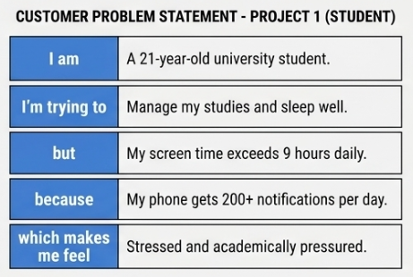
Example:
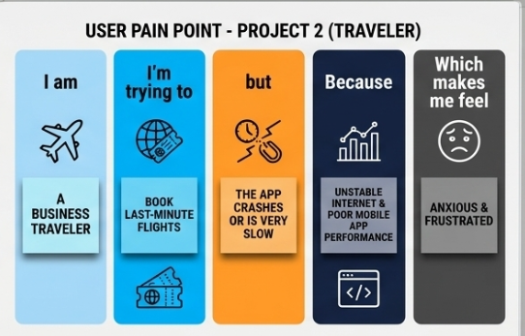

Problem  Statement (PS) | I am  (Customer) | I’m trying to | But | Because | Which makes me feel
PS-1 | A 21-year-old student juggling daily work and study responsibilities. | Maintain high productivity and balance my work/study hours efficiently. | I find myself constantly distracted by my phone, racking up over 9 hours of screen time daily. | My phone triggers over 200 notifications and hundreds of app opens a day, constantly breaking my focus. | Anxious, highly stressed, and out of control regarding my academic performance.
PS-2 | A 24-year-old smartphone user trying to maintain a healthy lifestyle. | Get a healthy night of rest and lower my daily stress levels. | My sleep is cut down to under 5 hours a night, while my weekend screen time spikes heavily. | I compulsively check social media and play mobile games late into the night, showcasing severe addiction behavior. | Exhausted, frustrated, and physically drained during the day.

